Boucher’s Comic Emporium

1. Introduction
   1. The key features of my project are a navbar, a newsletter button that opens a sign up modal, a jumbotron with color gradient, a carousel with 5 images and Font Awesome navigation arrows, multiple containers and columns, a blockquote element, three individual cards, and a footer containing links.
2. Design and Implementation
   1. While visualizing the original design, I set it up so that I could replicate it with multiple containers and columns. When I began to code, I worked on small pieces one at a time. I started from the top and worked down. I knew what pieces I wanted and where I wanted to place them so, I made some notes in my code to “outline” where certain parts would be and then began implementing the actual code for each piece.
   2. The color schemes are difficult for me as I don’t really have an eye for it. I wanted to go with bright vibrant colors but, after implementing these, realized they didn’t look great and tended to clash. I decided to go with a solid black navbar and footer with bright white links and navigation icons. Then I added a color gradient to my jumbotron. I also added a black and white blockquote in the middle of the page with three different colored cards at the bottom. I am not sure I like the overall color scheme of the website yet but, I am still working on this and will probably change it many more times in the future.
   3. The components I have used so far (listed in the introduction) were implemented because I have a basic understanding of how they work. This gave me the opportunity to dive a little deeper and do some additional styling or change icons and play around with the components that make it up along with the Bootstrap classes. I want to implement many more things so that I have a template in the future for most elements in Bootstrap, so I will continue to add these. At the moment, I am only “finished” with the home page. I want to use other pages to implement the other components , I just haven’t made it there yet. I want to look into doing a blog page, having a shopping page with cart components and a page with fun browser games once I get better with JavaScript, among other things. I will begin teaching myself these components and implementing them in the future.

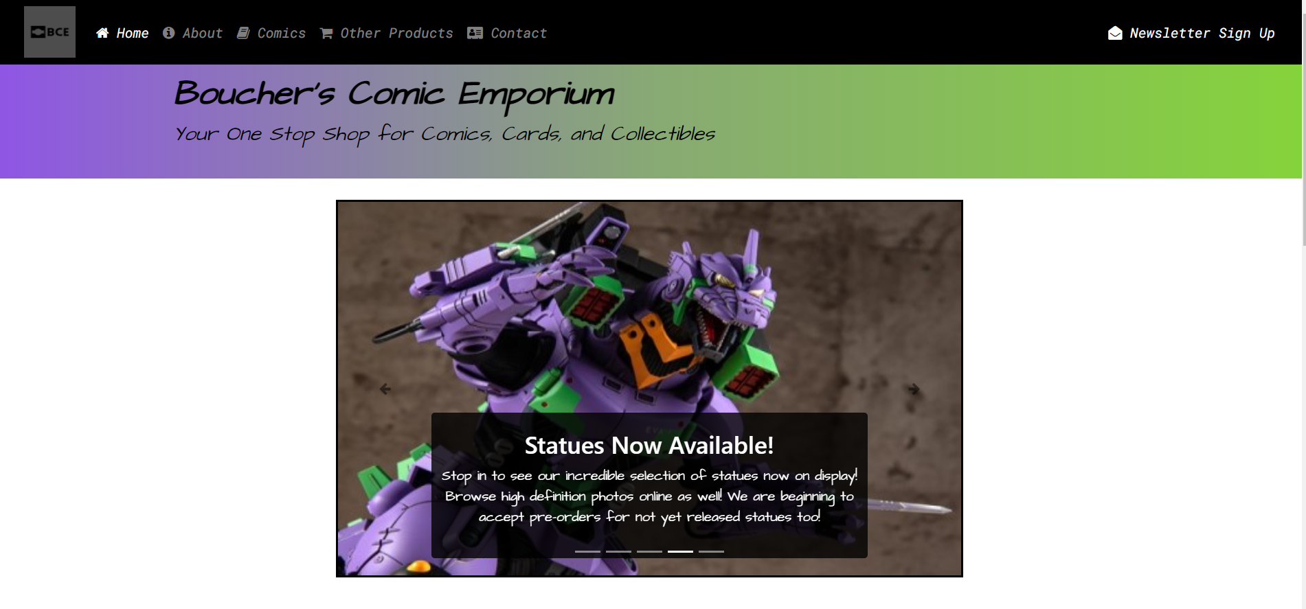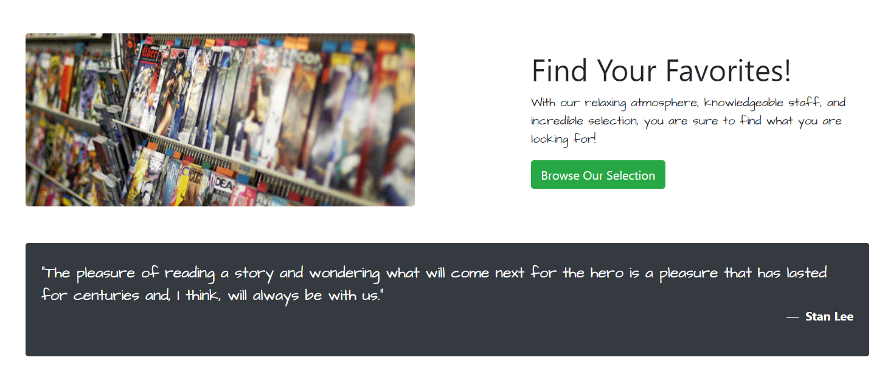

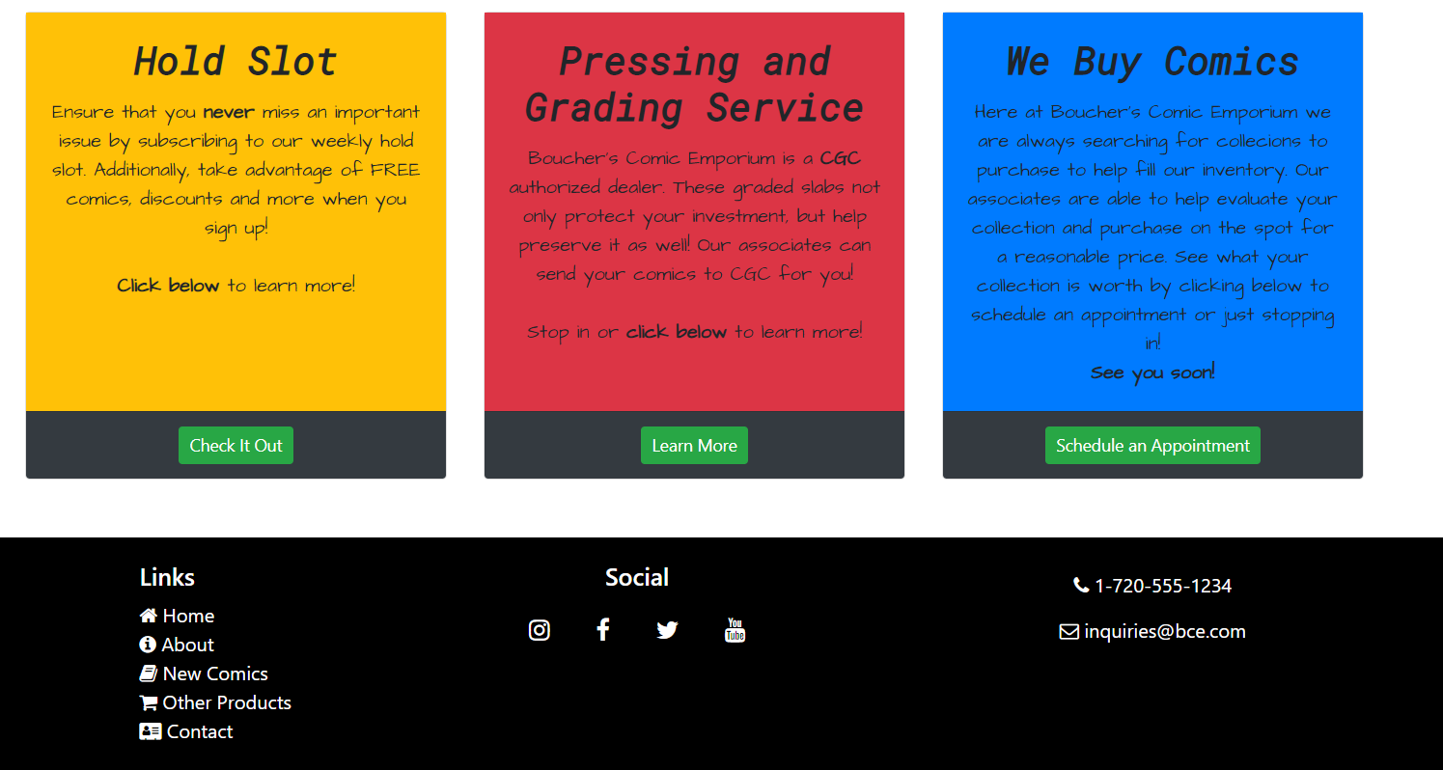

1. Conclusions
   1. Personally, I learned that one little error can cascade and mess up the entire document. It is very important to pay attention to the details.   
      I also learned that there is always someone out there (for the most part) that has tried doing what I am trying to do and has run into the same issues or at least similar issues. Stackoverflow is a fantastic resource for asking questions or reading through previously asked questions and then getting multiple answers.  
      Additionally, I learned that there are websites out there that allow me to download a bare bones framework for some of the components. This means that as long as I have an understanding of how the components work, I can easily implement it and tailor it to my personal liking.
   2. I think one of my best features is the newsletter sign up modal. I am really interested in collecting and working with user input data, so this really interested me. I really enjoyed doing the modal with the form element, although at the moment, I don’t know what to do with the data or how to receive it on the server. I am hoping the Full Stack class I am in will eventually teach me this.  
      My biggest shortcoming, I think, is the color scheme. I don’t mind it but, I don’t love it either. Also, I didn’t spend a lot of time on making a logo although I did want to have a logo to be able to program in the click to go home function. In the future, I want to work more with doing a logo and playing with fitting it into the navbar.
   3. I have already discussed this a little bit but, I would like to have a more professional looking logo and a better overall color scheme. I don’t know if this means I should do a totally different layout ( I don’t mind my layout) or just mess around with different colors. In the beginning I really wanted to do a lot of “superhero” colors since it is a comic website but I didn’t end up liking them. In hindsight, I may not have done a jumbotron element on top. I like it but, I don’t know if it is a little too much or not. I don’t want that to be the focal point when logging in, I want the carousel to be. I also may not do a gradient on the jumbotron.